SOFTWARE REQUIREMENT SPECIFICATION

HIRRA ZAHID

* FA21 – BCS – 139

HOSTEL MANAGEMENT SYSTEM

# PLANNING

### Objective

* + - To allow the admin to manage the room booking, room allocation, maintenance of student records, attendance tracking
    - To allow students to view their personal information, update their contact details, view their attendance details.
    - To manage housekeeping tasks such as cleaning schedules, room inspections, and maintenance requests. It should also be able to track the status of each room and generate work orders for repairs or cleaning.

### Stakeholders

* + - Admin
    - Student
    - Staff

### Policies

* + - A team of 5 experts with 2 years of experience will gather requirements from stakeholders.
    - Project manager will define the roles and responsibilities of each team member involved in the requirement gathering process.
    - Establish a timeline for requirement gathering and ensure that it is completed within the allocated time. This will help to ensure that the project stays on schedule.
    - Regularly review and refine the requirements to ensure that they remain accurate and relevant throughout the project.
    - Involve stakeholders in project to make sure that our project is up to their expectations.
    - If there is any change in requirements negotiate it with stakeholders and team members that what will the pros and cons of making the change. The top most priority would be given to the CEO decision after consultation with stakeholders.

### Tools

#### Questionnaires and Surveys:

We will administer to a large group of Stakeholders who in this case are students, hostel staff and housekeeping staff to gather feedback and suggestions for the hostel management system.

#### Document Analysis:

We will go through the existing documents such student records, attendance and rooms information to identify requirements and constraints. If document analysis will not work, we will go for group decision making technique

#### Facilitated Workshops:

We will hold meetings with our stakeholders to brainstorm ideas and develop requirements collaboratively.

### Summary

Hostel management software is a system that helps hostel owners and staff to automate their day-to-day tasks, making it easier to manage and monitor their hostel. The software can manage tasks such as room bookings, check-ins and check-outs, attendance, inventory management, add new students to hostel, allow student to view and update their information and report generation. With this software, hostel owners and staff can save time, reduce costs, and provide a better experience for their students and staff. The software can be customized to meet the specific needs of individual hostels, making it a versatile solution for hostel management.

# REQUIREMENT ELICITATION

## Admin

1. The software must allow admin to create, delete, update user accounts for students
2. The software must allow admin to create username and password for student and staff.
3. The software must allow admin to add, update and delete room information such as room number, room capacity.
4. The software must allow admin to allocate room to student and change the room if necessary
5. The software must allow admin to view all registered students
6. The software must allow admin to view available and occupied rooms.
7. The software must allow admin to view monthly revenue
8. The software must ensure the security of admin portal so that no one other than admin is able to edit hostel information.
9. Immediate changes must occur in the student portal when admin make changes in his portal like admission of a new student and other details

## Student

1. System should allow students to login using credentials provided by admin
2. System should allow students to view their personal information (their rooms information, their contact details etc.).
3. Students should be able to make request to change their room.
4. System should allow students to complain about any inconvenience in hostel.
5. System should allow students to update their contact information.
6. System should allow students to change their password.
7. System should allow students to view their pending dues
8. System should allow students to pay their dues online
9. There must be a feedback option for students to improve hostel facilities.
10. System must be available 24/7

## Staff

1. System should allow staff members to login using credentials provided by admin
2. The software must allow staff member to mark attendance on daily basis.
3. Staff should allow to mark rooms as "cleaned" once completed.
4. Staff should allow staff members to report damages or maintenance issues in the rooms they are cleaning.
5. Staff should allow staff members to request cleaning supplies and toiletries as needed.
6. Staff should allow staff members to view and update their assigned tasks.
7. Staff should allow staff members to communicate with admin

# RQUIREMENT ANALYSIS

Stakeholder meetings were utilized to conduct an assessment of collected requirements. To ensure clarity, conciseness, and consistency of the requirements, document analysis was employed. Ambiguous and indistinct requirements were distinguished based on their categorization into wishes, wants, prioritization, and validation.

## Classification

Requirement analysis is crucial in software development. It involves identifying, documenting, and verifying stakeholder needs. Functional and non-functional requirements are classified through the involvement of a board of software engineers and stakeholders. Proper analysis and classification can streamline development, reduce costs, and improve the quality of the final product.

## Functional Requirements

* + - Login page for student and staff
    - Options to edit hostel room details by admin
    - Creating credentials for staff and students
    - Allocation of rooms to student by admin
    - View all registered students
    - View occupied rooms to admin
    - View monthly revenue to admin
    - View student their personal information to themselves.
    - Complaining page for students
    - Changing portal password
    - View pending dues
    - Online fee payment for students
    - Room changing request option for students
    - Check mark for ‘room cleaned’ status
    - Page for reporting damages, for staff
    - Request for need of supplies for staff
    - Marking attendance
    - View assigned task to staff
    - Staff can update status of assigned task
    - Communication between admin and staff

## Non-Functional Requirement

* + - Security of portal
    - Students Feedback
    - Minimum response time
    - System 24/7 availability
    - Device independent system

## Conflict Resolution

Conflicting stakeholder requirements were resolved through a process of negotiation and balance. Meetings were held where stakeholders presented their views to software experts, and the team worked together to accept and reject requirements based on stakeholder opinions and a calculated approach to conflict resolution. This process ensured that all stakeholders were heard and that a mutually agreeable solution was reached.

## Prioritization

All requirements were prioritized based on points assigned by stakeholders, with high- ranking officials being given more weight to balance the requirements. The team assigned minimal importance to less prioritized requirements, ultimately designating them as low priority. By utilizing a points-based prioritization system, the team was able to allocate resources

effectively and ensure that high-priority requirements were given the necessary attention and resources to meet stakeholders' needs.

## Validation

The validation of each requirement was performed by subject matter experts, who reviewed and followed the reconsideration process with all stakeholders. This approach ensured that all requirements were thoroughly examined and verified before being implemented, reducing the likelihood of errors or oversights. The involvement of subject matter experts in the validation process also helped to ensure that requirements were technically feasible and aligned with industry best practices, ultimately resulting in a higher quality final product.

# REQUIREMENT SPECIFICATION

At this stage, only the accepted requirements will be incorporated into the final product. The rejected requirements will not be included in the system, as they were deemed unsuitable based on the reasons provided. By excluding rejected requirements from the development process, the team can focus their efforts on the most important and feasible requirements, ensuring that the final product meets the needs and expectations of all stakeholders involved.

## Accepted Requirements Functional Requirements

* + 1. Admin must be able to create, delete, and update user accounts for students.
    2. Admin must be able to add, update and delete room information such as room number, room capacity.
    3. Admin must be able to allocate a room to a student and change the room if necessary.
    4. Admin must be able to monthly revenue
    5. Admin must be able to view available and occupied rooms.
    6. Admin must be able to view all registered students
    7. Students should be able to view their personal information (their room's information, their contact details, etc.).
    8. Students should be able to make a request to change their room.
    9. Students must be able to change their password.
    10. Housekeeping staff should be able to mark rooms as "cleaned" once completed.
    11. Housekeeping staff should be able to report damages or maintenance issues in the rooms they are cleaning.
    12. Housekeeping staff should be able to view and update their assigned tasks.

## Non-Functional Requirements

1. Privacy of information, the export of restricted technologies, intellectual property rights, etc. should be audited.
2. Only administrator is authorized to update critical data about staff and students although staff and students can update their data like personal information and their password.
3. The system should response a user within 2 seconds
4. The system should support the HTML browser.
5. Software should be operating system independent.
6. The software must be compatible with a wide range of devices
   1. **Rejected Requirements**

|  |  |
| --- | --- |
| **Requirement** | **Rejection Reason** |
| The software must allow admin to view monthly revenue | This is linking the software to the finance department that’s why it should be excluded because it is beyond the scope of the project |
| System should allow students to view their pending dues | This requirement is beyond the scope of the project |
| Staff should allow to request cleaning supplies and  toiletries as needed. | Hostel should have a separate channel to deal with this issue, this software is not intended to track this requirement. |
| Software should be operating system  independent. | This is wastage of resources and wastage of time as well as we have to hire additional programmers to deal that also  operating systems before 2008 are obsolete, so it is rejected. |
| The software must be compatible with a wide range of devices | The cost and complexity of ensuring compatibility with a wide range of devices is too high. |

1. **REQUIREMENT TRACEBILITY MATRIX**

|  |  |  |  |  |  |
| --- | --- | --- | --- | --- | --- |
| **SID** | **RID** | **Requirement Description** | **Use Case** | **Test Case** | **Project Objective** |
| **SID- 001** | RID- 001 | The system should allow authorized admin to manage student user accounts, including personal and room information. | UID- 001 | TID- 001 | Secure and efficient  management of student user accounts by admin, with accurate and up-to-date  personal and room  information for administrative purposes. |
| **SID- 002** | RID- 002 | This system will allow the admin to allocate the room to the student based on the availability of rooms. | UID- 002 | TID- 002 | Efficient and user-friendly room allocation system for admin based on availability, ensuring suitable  accommodations for all students and reducing administrative overhead. |
| **SID- 003** | RID- 003 | This system will allow the student/Housekeeping staff member to lodge any complaint related to the hostel and admin. | UID- 003 | TID- 003 | Streamlined complaint lodging system for students and housekeeping staff, ensuring timely resolution of issues and promoting a positive living  environment in the hostel. |
| **SID- 004** | RID- 004 | This will allow the housekeeping staff member to mark the room as cleaned after cleaning the room | UID- 004 | TID- 004 | Efficient room cleaning status tracking system for  housekeeping staff, ensuring proper maintenance of all rooms and reducing  administrative overhead. |
| **SID- 005** | RID- 005 | This will allow the Admin member to mark the attendance of the students. | UID- 005 | TID- 005 | To provide a user-friendly system for admin to mark attendance for students, |

|  |  |  |  |  |  |
| --- | --- | --- | --- | --- | --- |
|  |  |  |  |  | ensuring accurate record- keeping and reducing administrative overhead. |
| **SID- 006** | RID- 006 | This will allow the student to enter the feedback about the hostel. | UID- 006 | TID- 006 | Accessible system for student feedback about the hostel, promoting a positive living  environment and continuous improvement of facilities and services. |

1. **WORK BREADDOWN STRUCTURE**

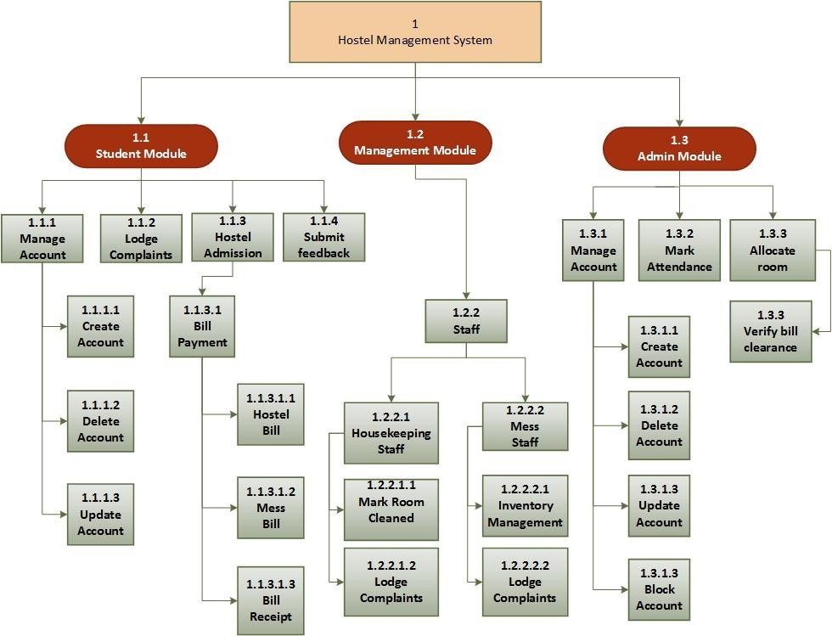

1. **USE CASES**
2. **Use Case 1**

|  |  |
| --- | --- |
| <USE CASE ID : Create, Delete, Update User Account for Student> | |
| PRIORITY | 1 |
| ACTORS | Admin |
| Use Case Summary | This will allow the admin to create, delete, update user accounts for students, which include personal information such as name, contact details, and room  information. |
| Pre-condition: | Admin member is logged into the software.  Admin member must be authorized to take the attendance.  Student’s data must be in database if the staff member tries to update or delete  information. |
| Steps | |
| 1. | If admin member selects the "Create User Account" option from the software's main menu. |
| 2. | Admin member enters the student's personal information, such as name, contact details, and room information. |
| 3. | Admin member submits the information to create the user account. |
| 4. | Software verifies that the entered information is valid and creates the user account for the student. |
| 5. | Software displays a confirmation message to the admin member. |
| 6. | If admin member selects the "update User Account" option from the software's  main menu. |
| 7. | Software verifies that the entered information is valid and the user account for  the student exists. |
| 8. | Admin member will enter the new information |
| 9. | Software will update the information of student |
| 10. | Software displays a confirmation message to the admin member. |
| 11. | If admin member selects the "delete User Account" option from the software's  main menu. |
| 12. | Software verifies that the user account for the student exists. |
| 13. | Software will delete the information of student |
| 14. | Software displays a confirmation message to the admin member. |
|  |  |
| ALTERNATE SCENARIO: Entered Information is incomplete or invalid | |

|  |  |
| --- | --- |
|  | |
| 1a. | If Software detects that the entered information is incomplete or invalid, it will display an error message to the admin member. |
| EXCEPTIONS / ALERT | |
| 1. | If admin member is creating a new account for the new student the system will not allow the admin member to submit the information of a student who is  already living in hostel. |
| 2. | The system will not allow to delete or update the information of student who  does not exists in database |
| POST CONDITIONS | |
| 1. | User account is created for the student. |
| 2. | User account is updated for the student. |
| 3. | User account is deleted for the student. |
|  |  |
| USE CASE CROSS REFERENCES | |
| Includes | None |
| Extends | None |
|  |  |

1. **Use Case 2**

|  |  |
| --- | --- |
| <USE CASE ID : Allocate Room to Student> | |
| PRIORITY | 2 |
| ACTORS | Admin |
| Use Case Summary | This will allow the admin to allocate the room to the student based on the availability of rooms. |
| Pre-condition: | Admin member is logged into the software.  Admin member must be authorized to take the attendance. Room is available. |
| Steps | |
| 1. | Admin member selects the "Allocate room" option from the software's main menu. |
| 2. | Admin member selects a room that is available and matches the student's  requirements. |

|  |  |
| --- | --- |
| 3. | Admin member enters the student's information, such as name and student ID number. |
| 4. | Admin member submits the information to allocate the room to the student. |
| 5. | Software verifies that the entered information is valid and assigns the room to the student. |
| 6. | Software updates the availability status of the room. |
| 7. | Software displays a confirmation message to the admin member. |
| ALTERNATE SCENARIO : Room is not available | |
| 1a. | If Software detects that the room is not available then no room will be allocated to the student. |
| EXCEPTIONS / ALERT | |
| 1. | The system will make an alert for the already allocated rooms if the admin  member will try to allocate the already allocated room. |
| POST CONDITIONS | |
| 1. | Student is assigned a room. |
| USE CASE CROSS REFERENCES | |
| Includes | None |
| Extends | None |

1. **Use Case 3**

|  |  |
| --- | --- |
| <USE CASE ID : Lodge Complaints> | |
| PRIORITY | 4 |
| ACTORS | Student, Housekeeping staff member |
| Use Case Summary | This will allow the student/Housekeeping staff member to lodge any complaint related to the hostel and admin |
| Pre-condition: | Student/Housekeeping staff member is logged into the software. |
| Steps | |

|  |  |
| --- | --- |
| 1. | Student / Housekeeping staff member selects the "Lodge Complaint" option from the software's main menu. |
| 2. | Student/ Housekeeping staff member describes the problem or inconvenience in detail. |
| 3. | Student/ Housekeeping staff member submits the complaint. |
| 4. | Software/ Housekeeping staff member displays a confirmation message to the student. |
| ALTERNATE SCENARIO : None | |
| EXCEPTIONS / ALERT | |
| 1. | None |
| POST CONDITIONS | |
| 1. | Complaint is lodged and recorded in the system. |
| USE CASE CROSS REFERENCES | |
| Includes | None |
| Extends | None |
|  |  |

1. **Use Case 4**

|  |  |
| --- | --- |
| <USE CASE ID : Mark Room as Cleaned> | |
| PRIORITY | 2 |
| ACTORS | Housekeeping Staff |
| Use Case Summary | This will allow the housekeeping staff member to mark the room as cleaned after cleaning the room |
| Pre-condition: | Housekeeping staff member is logged into the software.  Housekeeping staff member must be authorized to mark the room cleaned. |
| Steps | |
| 1. | Housekeeping staff member selects the "Mark Room as Cleaned" option from the software's main menu. |

|  |  |
| --- | --- |
| 2. | Housekeeping staff member selects the room they have just cleaned. |
| 3. | Housekeeping staff member submits the information to mark the room as cleaned. |
| 4. | Software verifies that the entered information is valid and updates the status of the room in the system. |
| 5. | Software displays a confirmation message to the housekeeping staff member. |
| ALTERNATE SCENARIO: Selects the wrong room by mistake. | |
| 1a. | Housekeeping staff member receives a message that the selected room does not match their assigned tasks and is prompted to select the correct room. |
| EXCEPTIONS / ALERT | |
| 1. | The system will make an alert for the already cleaned rooms if the housekeeping  staff member will try to mark the already cleaned room. |
| POST CONDITIONS | |
| 1. | Room is marked as cleaned in the system. |
| USE CASE CROSS REFERENCES | |
| Includes | None |
| Extends | None |

1. **Use Case 5**

|  |  |
| --- | --- |
| <USE CASE ID : Mark Attendance> | |
| PRIORITY | 2 |
| ACTORS | Admin member |
| Use Case Summary | This will allow the Admin member to mark the attendance of the students. |
| Pre-condition: | Housekeeping staff member is logged into the software.  Housekeeping staff member must be authorized to mark the room cleaned. Student must be present in the database. |
| Steps | |

|  |  |
| --- | --- |
| 1. | Admin member selects the "Mark Attendance" option from the software's main menu. |
| 2. | Admin member marks the attendance |
| 3. | Admin member submit the attendance |
| 4. | Software displays a confirmation message to the Admin member. |
| ALTERNATE SCENARIO: Selects the cancel button by mistake. | |
| 1a. | Housekeeping staff member receives a message that attendance has not been submitted. |
| EXCEPTIONS / ALERT | |
| 1. | The system will make an alert for the already marked attendance |
| POST CONDITIONS | |
| 1. | Student will be marked as present |
| USE CASE CROSS REFERENCES | |
| Includes | None |
| Extends | None |

1. **Use Case 6**

|  |  |
| --- | --- |
| <USE CASE ID : Submit Feedback> | |
| PRIORITY | 3 |
| ACTORS | Student |
| Use Case Summary | This will allow the student to enter the feedback about the hostel. |
| Pre-condition: | Student is logged into the software. Student must be present in the database. |
| Steps | |
| 1. | Student selects the "submit feedback" option from the software's main menu. |
| 2. | Student writes the feedback |
| 3. | student submits the feedback |
| 4. | Software displays a confirmation message to student. |

|  |  |
| --- | --- |
|  |  |
| ALTERNATE SCENARIO: Selects the cancel button by mistake. | |
| 1a. | Student receives a message that feedback has not been submitted. |
| EXCEPTIONS / ALERT | |
| 1. | The system will make an alert for the already submit feedback .One student can  submit a feedback only once. |
| POST CONDITIONS | |
| 1. | Student will be marked as done |
| USE CASE CROSS REFERENCES | |
| Includes | None |
| Extends | None |
|  |  |